|  |  |
| --- | --- |
| Date | 24October 2022 |
| Team ID | PNT2022TMID414052 |
| Project Name | Real time River Water Quality Monitoring and Control System |

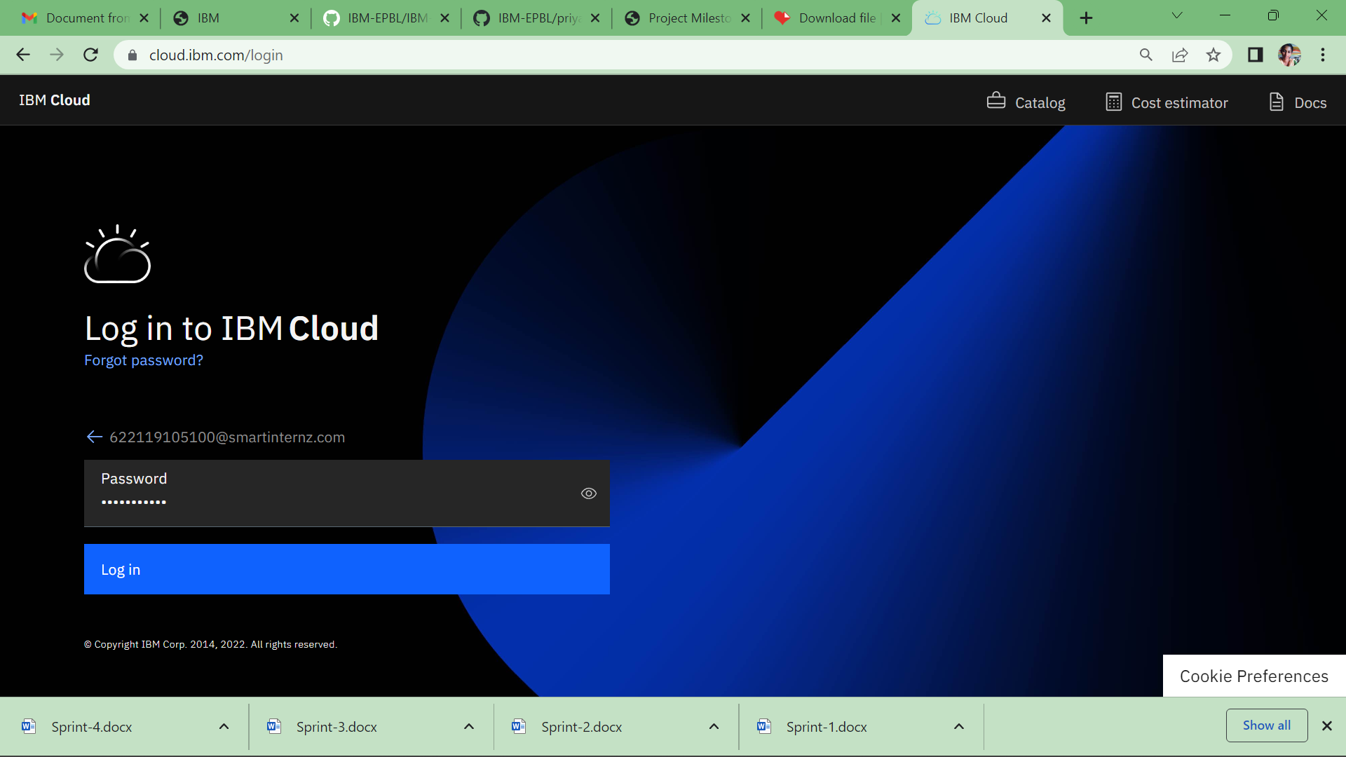

Created an IBM cloud

